**Request packet:**

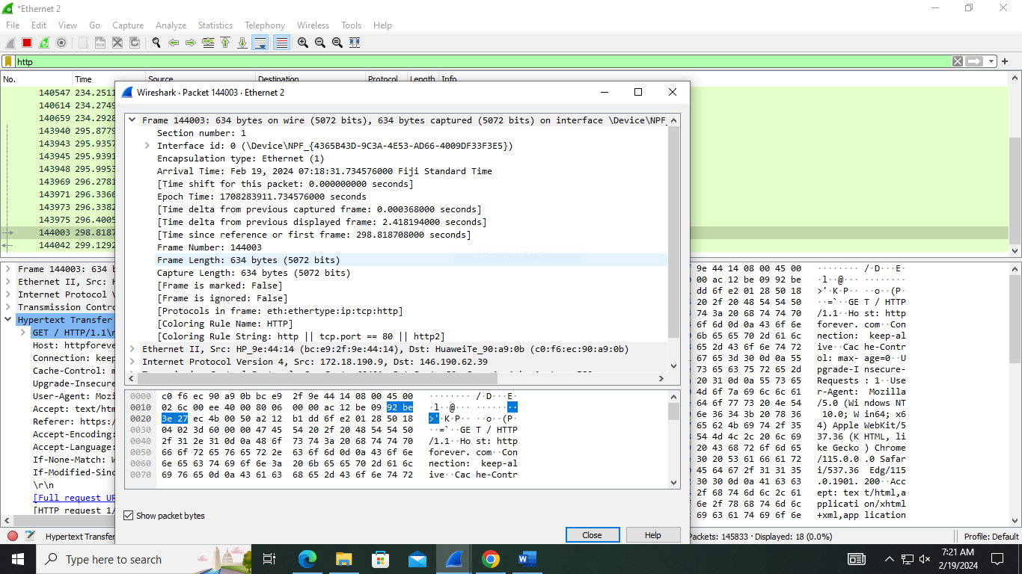

This is a Physical layer for request packet, it contains the number of frame number, frame length, encapsulation type, arrival time.

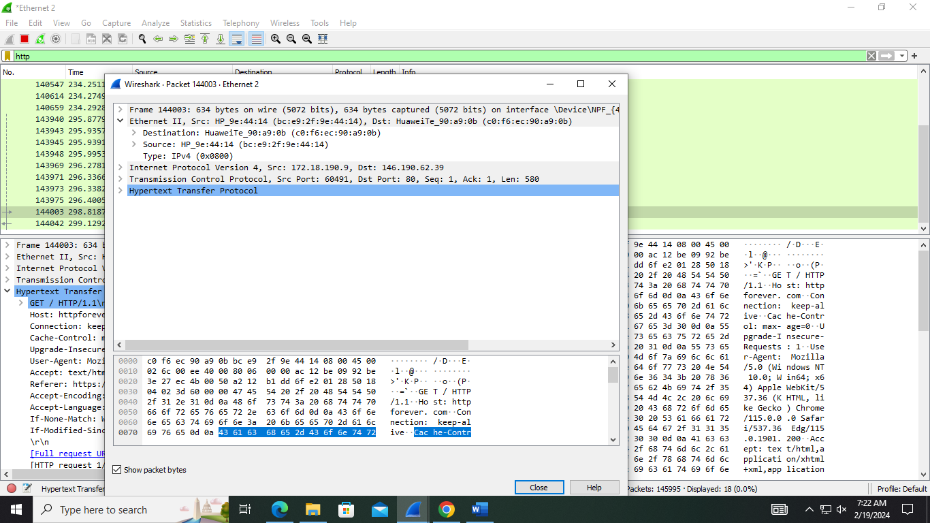

This a data link layer where the destination mac address is c0:f6:ec:90:0b and source mac address is bc:e9:2f:9e:44:14

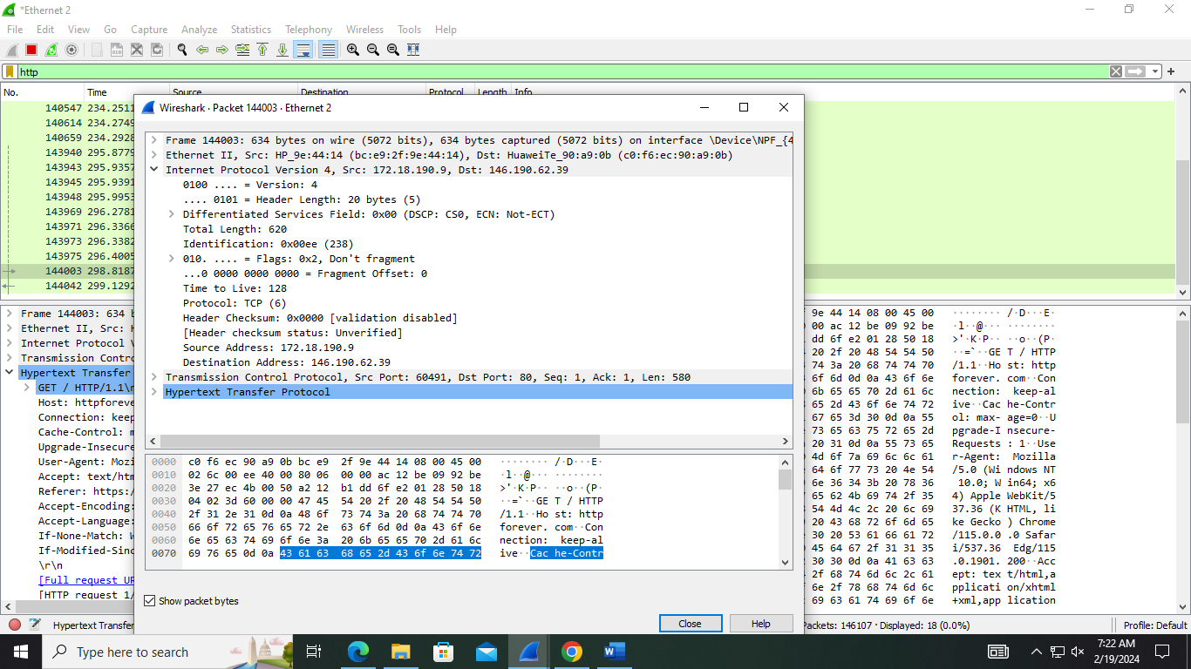

This portion is for Network layer. In this layer the Ip address of source is 172.18.190.9 and destination Ip address is 146.190.62.39

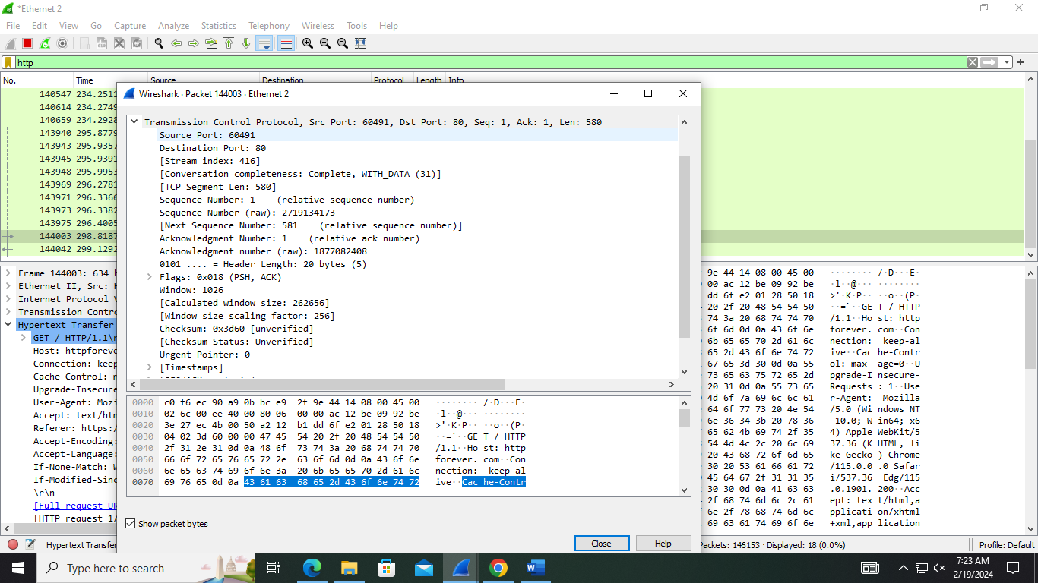

This portion is representing the Transport layer. Source port is 60491 and destination port is 80 which is a web port. Header length is 20 byte, checksum is 0X3d60, urgent pointer is 0 this layer is following TCP

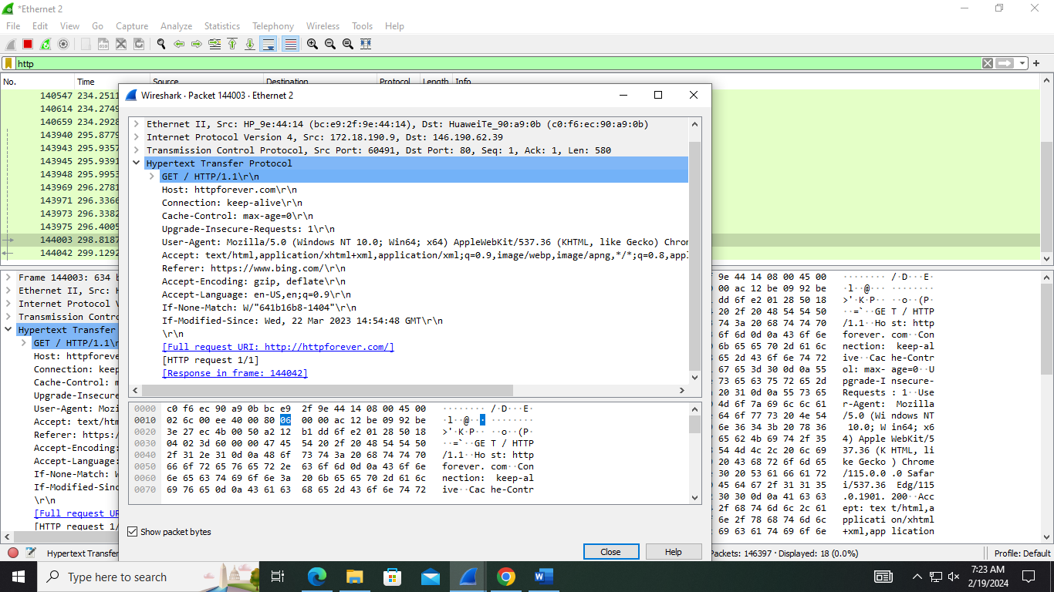

This is an Application layer. The host is httpforever.com using a persistent connection as the connection: keep-alive header is present.

**Response packet:**

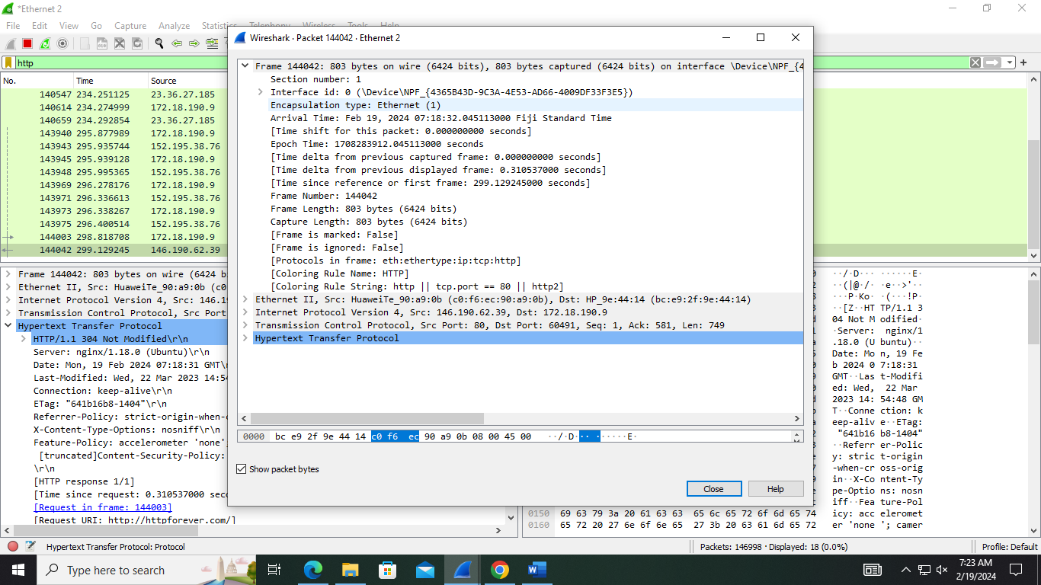

This is a Physical layer for request packet, it contains the number of frame number, frame length, encapsulation type, arrival time.

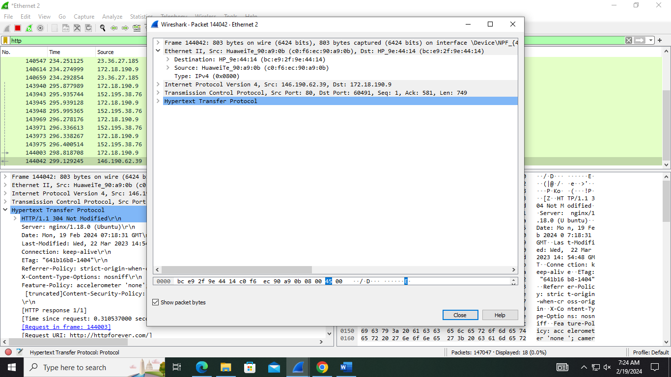

This a data link layer where the destination mac address is bc:e9:2f:9e:44:14 and source mac address is c0:f6:ec:90:0b

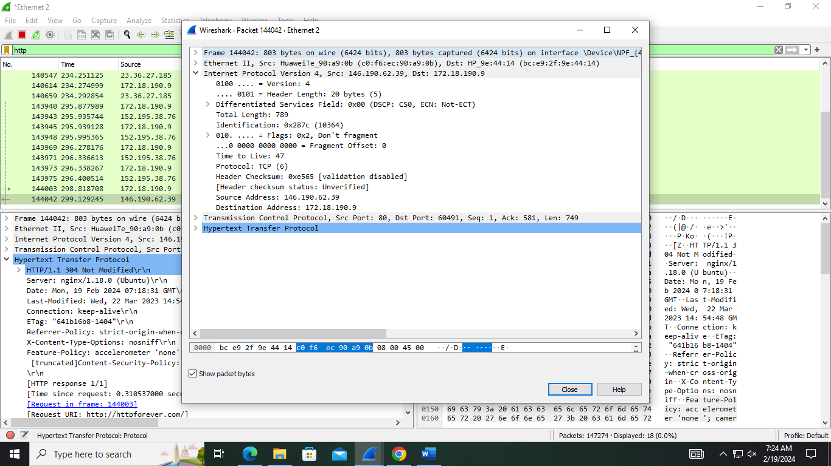

This portion is for Network layer. In this layer the Ip address of source is 146.190.62.39 and destination Ip address is 172.18.190.9

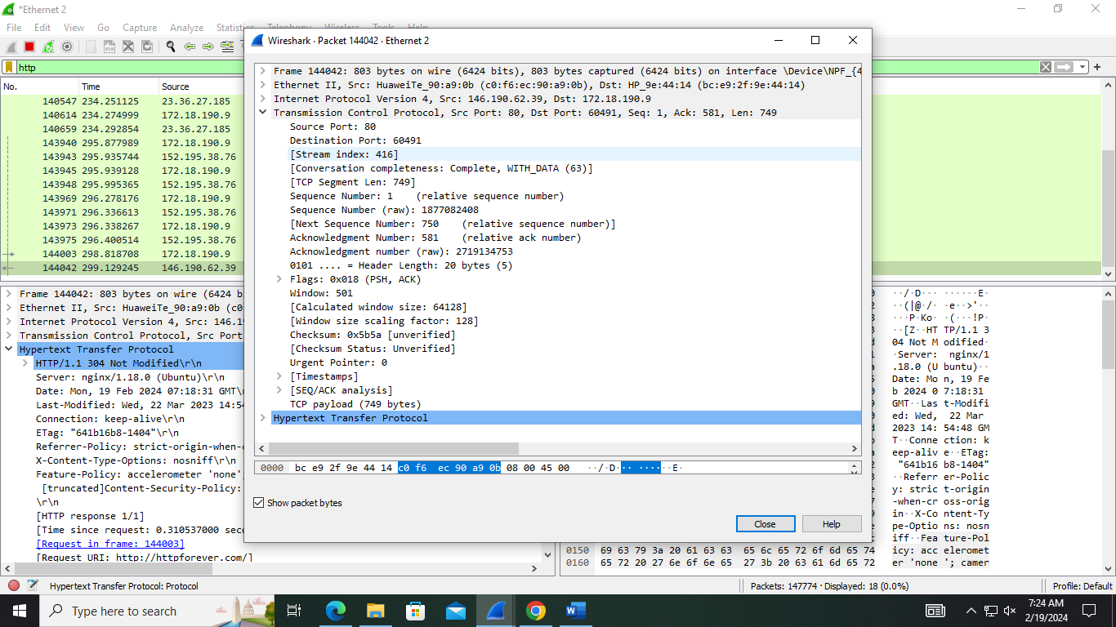

This portion is representing the Transport layer. Source port is 80 and destination port is 60491which is a web port. Header length is 20 byte, checksum is 0X5b5a, urgent pointer is 0 this layer is following TCP

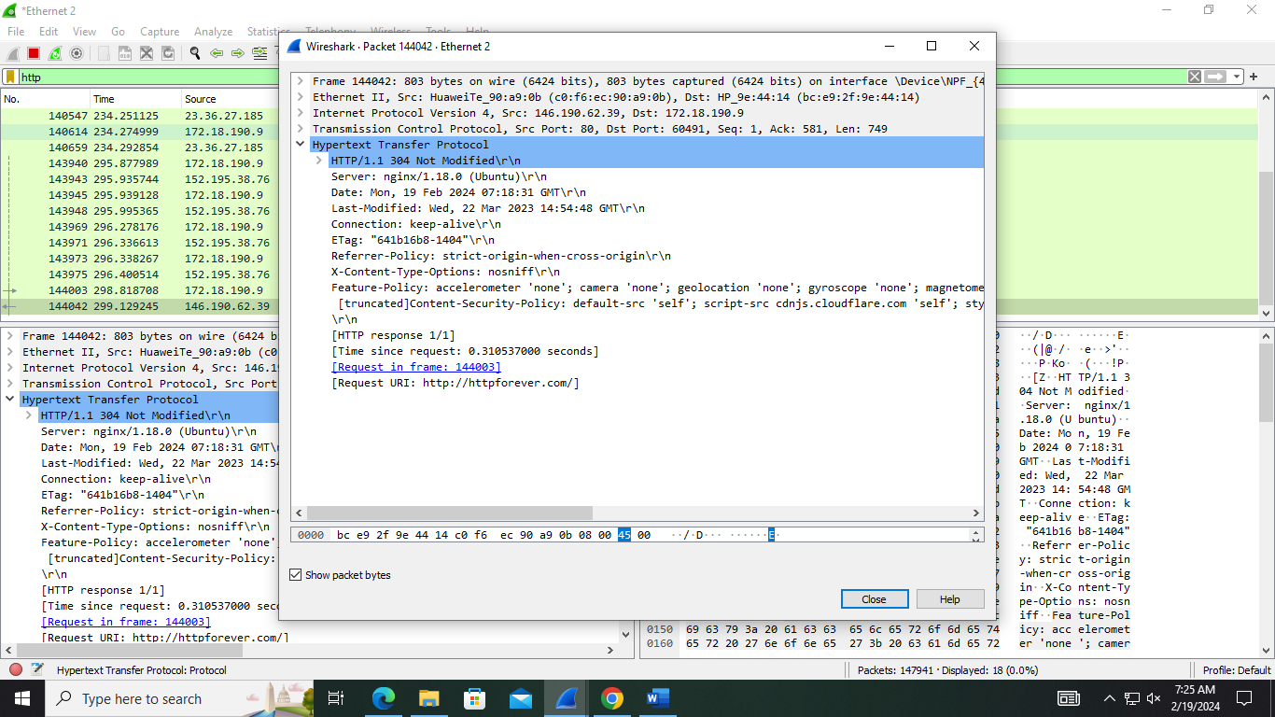

This is an Application layer. The host is httpforever.com using a persistent connection as the connection: keep-alive header is present. The header status is 304 not modified. The last modification time is also present.